Measurement of the Angular Dependency of Solar Cells

34553 Applied Photovoltaics

**August 2020**

**Abstract:** In this exercise you will investigate how the performance of solar cells changes as a function of angle of incidence. You will use the measured data to derive the incidence angle modifier.

References and links

* Slides from class (Block 3)
* K. Mertens Chapter 3.6.2
* <https://pvpmc.sandia.gov/modeling-steps/1-weather-design-inputs/shading-soiling-and-reflection-losses/incident-angle-reflection-losses/>

**Safety**

* Always wear UV protection goggles when the light source is on.

1. Introduction

Unless solar panels are mounted on a two-axis tracker, they will spend a significant amount of time oriented at non-ideal angles of incidence (AOI) relative to the sun. This poses an issue since solar panels with relatively smooth soda-lime glass superstrates show pronounced reflection losses at AOIs beyond 45°. The incident angle modifier (IAM) profile characterizes the relative transmission of a PV device. The IAM is used by PV modelers to calculate reflection losses and energy yield. In this lab exercise you will derive the IAM profiles for c-Si single cell samples with three different glass types. The glasses include 4mm finely textured glass (Albarino T), 4mm deep structured glass (Albarino G), and a grey tinted float glass (PAMSOL).

1. **Theory**

As shown in the class lecture when light falls on an interface of two materials with different refractive indices, some of the light is reflected and some is refracted (Figure 1). PV manufacturers sometimes apply anti-reflective coatings (ARC) to minimize the amount of reflection. This is accomplished by coating the glass with multiple thin-film layers that modify the refractive index of the glass such that it better matches the refractive index of ambient air.

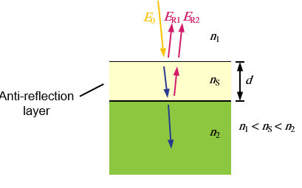

Figure 1: Reflection of light at the interface of a two layer stack with ARC (ns) and glass (n2). Source: K. Mertens Figure 3.23

Additional methods such as texturing the glass can also mitigate reflection loss through improved light trapping at the glass-air interface.

1. Experimental setup

The block diagram of the measurement system you will use to characterize angular dependent losses is shown in Figure 2. This system is used by the Applied Photovoltaics (APV) team to measure IAM profiles of single cell samples and to provide a better understanding of expected field performance. Although the light source does not completely illuminate the entire PV sample, and the irradiance within the illuminated area is less than 1000 W/m2, we have demonstrated that the measurements performed in this system are comparable to measurements performed by accredited labs in Europe and the United States.[1]

The light source is an EQ-99XFC laser driven light source (LDLS) from Energetiq. The light is generated via a continuous wave (CW) laser that focuses onto a proprietary bulb. The high heat generated by the laser converts the Xenon gas inside the bulb into a plasma state. The plasma has a high UV component (190 - 400 nm), which is why there is a UV filter mounted in the light path. The acrylic box that covers the optical bench provides UV protection, but we will wear UV protective goggles during the test for extra safety. The off-axis parabolic mirrors collimate the light onto the sample, which is needed because the IAM test assumes all photons are coming from a single direction. The aperture mitigates stray light and further improves collimation. The device under test (DUT) is mounted on a rotation stage that is controllable through a LabVIEW interface. The short circuit current (ISC) and temperature are logged with a National Instruments (NI) datalogger. All data are written to a .txt file for post processing and analysis.

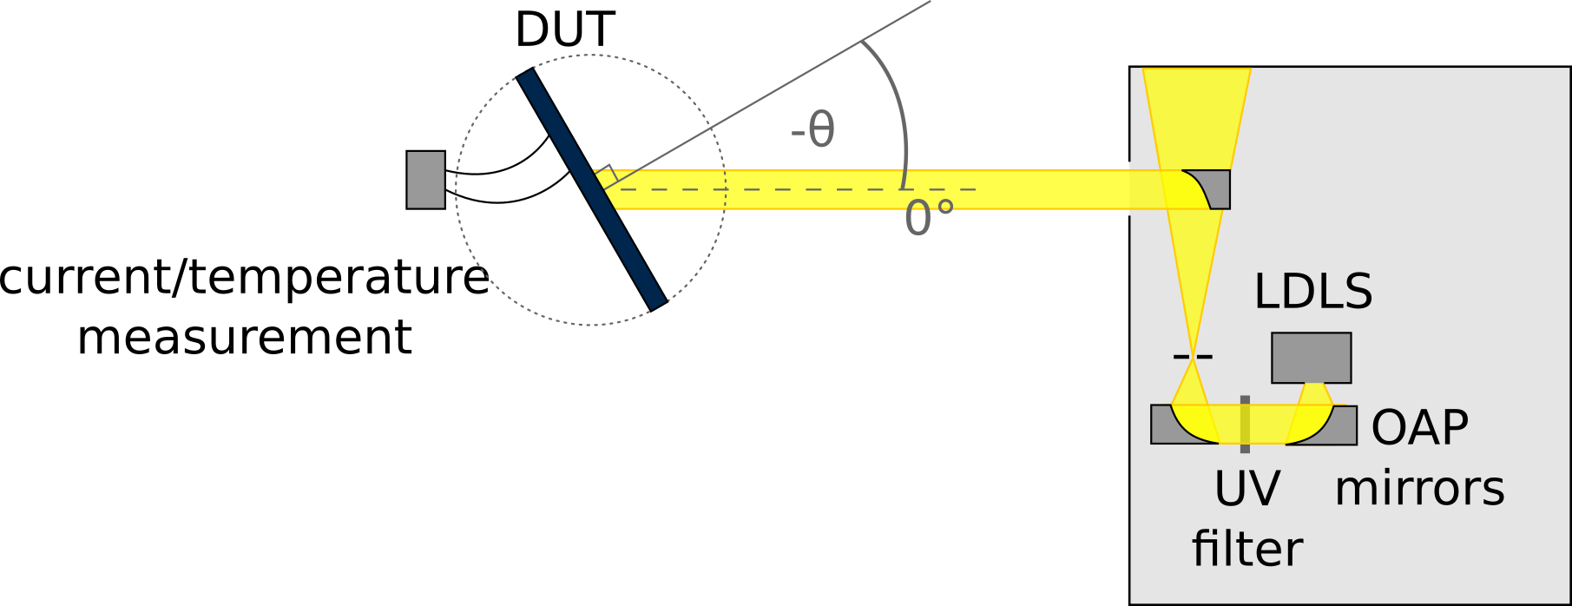

Figure 2: Block diagram of the optical bench for measuring angular dependence of solar cells.[2]

1. **Experimental Methods**

For safety reasons, always wear UV protection goggles when the light source is on!

Note that the LDLS needs at least 30 minutes to warm up and stabilize.

An instructor will guide you through the following procedure:

1. Turn on the LDLS power supply located underneath the test setup. First turn the switch on the back of the unit on and then the button on the front.

|  |  |
| --- | --- |
| IMG-1015 | C:\Users\Nicholas Riedel\AppData\Local\Microsoft\Windows\INetCache\Content.Word\IMG-1016.jpg |

Figure 3: Left) On switch located on the back of the power supply. Right) On button located on the front of the power supply.

1. Once the LDLS has been turned on, you need to turn on the safety light, which notifies people outside of the room that the light source is on (Figure 4).

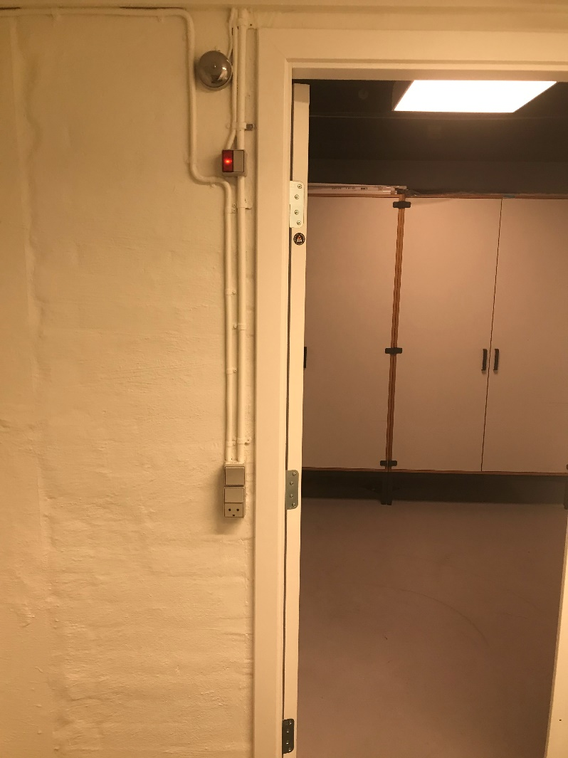

Figure 4: Picture of the switch to turn on the safety indicator light.

1. Place the j-type thermocouple (TC) on the backsheet of your test sample using Kapton tape.
2. Mount the test sample in the aluminum sample holder frame. Please note that the DC motor at the base of the sample holder is sensitive to vibrations and forces applied when mounting the sample and can get damaged. **Extreme care should be taken during this process.** Use both hands, one holding the sample holder at all times and working with the other one. Figure 5 shows an example of how the sample should be placed.
   1. In the left image of Figure 5, note the horizontal profile on top of the test sample. There are two M6 sliding nuts attached to this profile that allow it to be moved up and down for placement and removal of the sample.
   2. The right image of Figure 5 shows an example of hand tightening the screws on the back of the sample. This is done as a final adjustment to fasten the sample in place.

|  |  |
| --- | --- |
| **IMG-1022** | **IMG-1023** |

Figure 5: Mounting the test sample in the holder. Left) Tightening the M6 screws on top of the sample. Note that this profile can slide freely allowing you to place and remove the sample. Right) Example of hand tightening the set screws on the back to secure and align the sample.

1. It is important that the sample rotates in a direction such that the light does not illuminate the bus bars – note the horizontal bus bar placement in Figure 5.
2. With the sample in its home position (facing the light source at 0° AOI), check the alignment with the cross-hair laser cube. You must check alignment from two points: from the back and side. The on button of the laser cube must be pressed three times to get the cross-hair function.
   1. Move the cross-hair laser to the **back** of the sample:
      * Align the vertical line of the cross-hair laser with the vertical line of the motor base, by adjusting the cross-hair laser.
      * Align the vertical line of the sample holder with the vertical line of the cross-hair laser by adjusting the position of sample holder using the micro adjustor (Figure 6).

|  |  |
| --- | --- |
|  |  |

Figure 6: Left) Picture of laser cube projecting a vertical laser onto the back of the motor base and sample holder. Right) White markers on the motor base and sample holder that must both intersect the laser line. The pictures of the marks are highlighted in red and the micro adjuster is highlighted in blue.

* 1. From the **edge** of the sample: check that the 90° mark on the motor base is well aligned with the solar cell (Figure 7). This will ensure that the axis of rotation is in the middle of the cell (i.e. the PV cell itself). Use the micro adjuster to improve the alignment.

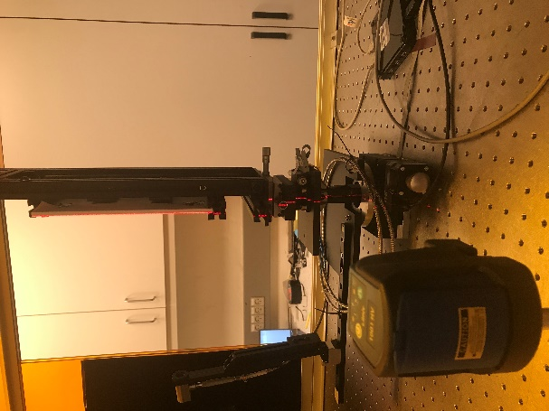

Figure 7: Picture of laser cube projecting a vertical laser onto the glass edge of the sample and the edge of the sample holder.

1. Connect the leads of the solar cell to the shunt resistor using the alligator clips (Figure 8).

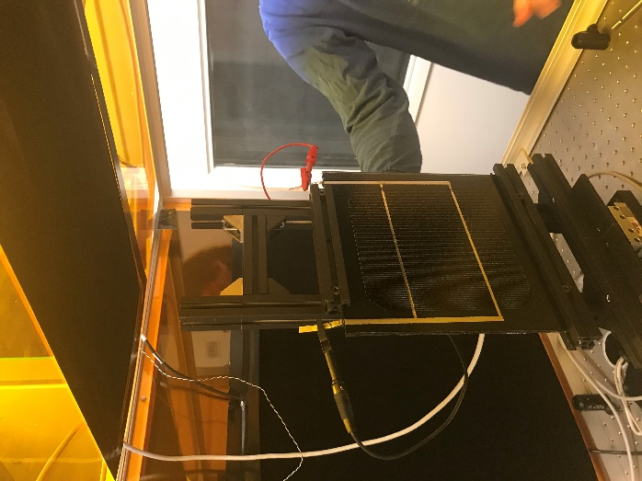

Figure 8: Sample with alligator clips connected to the correct polarity (black = negative, red = positive).

1. Open *V5_AOI Test Program_Ni9213_Dual Motor_beta10.vi* from LabVIEW. Perform the following steps in the interface as indicated in Figure 9.
   1. Click the black arrow in the top left of the interface to run the program.
   2. Pick a folder to save the measurement files. In this example, the files will be written to the desktop.
   3. Record the details of the test sample in the LabVIEW interface in the ‘Sample Number´ field. This information will be written in the data file name. In this example, the sample number is NaN.
   4. From the Acq Setting tab, configure the voltage and temperature channels as displayed in the GUI annotation.
   5. From the ‘AOI Measurement’ tab, vary the AOI between the solar cell normal and the optical axis of the light source using a ‘Start Angle’ of 0°, a ‘Stop Angle’ of 80°, and a ‘Angle Step Size’ of 5°.
      * Select the Rotation Motor as TDC 001-CR1/M-27
   6. Set the initial position of the motor by pressing the **Send to home position button**
   7. Turn off lights
   8. Click “Start AOI Test” in the bottom left corner.
   9. Once the test is complete and the .txt file is saved, click “Send to Home Position”.

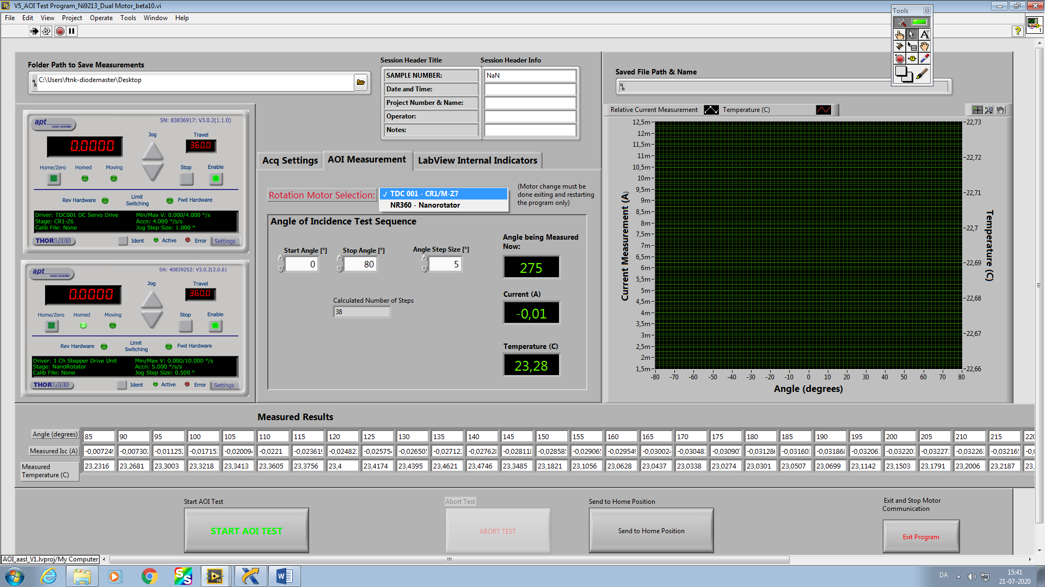

F

H

E

C

B

A

Figure 9: Screenshot of the LabVIEW interface and letters indicating the menus/settings to use at each step of the workflow.

1. Dismount the alligator clips, the test sample, and the TC (in that order). Repeat steps 8c-8f for the remaining samples.
2. When all samples are measured press “Exit Program” in the bottom right hand corner. Switch off the light source and safety indicator light. **Don’t** turn off the PC!

The measured short circuit current (ISC), AOI, and temperature data will either be given to you on a USB drive or uploaded to Learn as .txt files (one file for each sample measured).

Note that when calculating the IAM curves, you do not need to apply a cosine correction! The reason for this is due to the partial illumination of the test sample: all the light that impinges upon the cell at normal incidence still impinges upon the cell when it’s at an angle. Therefore, use the following equation to calculate the IAM curve. Where *ISC(0°)* is the short circuit current measured at normal incidence and *ISC(θ)* is the short circuit current measured at the respective AOI, *θ.*

1. **Presentation (~3 slides)**
2. Explain the measurement theory and relevant equations.
3. Show plots of the derived IAM curves as a function of AOI. Which glass shows the best angular performance in terms of the IAM? Comment on this benefit.
4. Fit the measured IAM curves to the Martin and Ruiz model (equation shown below).[3] Where *θ* is the AOI and *ar* is the angular loss coefficient. The higher the value of*ar* the higher the angular losses (i.e. more reflection).

Extract the parameter *ar* for each glass using a least-squares regression. You can use *Solver* in Excel or a similar fitting tool. A good starting value for *ar* is 0.15. If you need help with fitting your measured IAM data to the model, ask the instructor. **Display the three *ar* coefficients (one for each glass) and the goodness of fit in a table in the presentation.**

1. Once you have obtained the *ar* coefficients, you can then calculate the “effective DNI” that would be received by the cell.[4] Using the clear sky DNI and corresponding AOI data for that day, calculate the “effective DNI” for each sample per the equation below. Use the data provided in Table 1. Add three *DNIeff* columns to this table, one for each sample.

Integrate *DNIeff* over the whole day to obtain *DNIeff* in Wh/m2 for each sample. **Compare the three values of *DNIeff* and show how much more direct beam irradiance (on a percentage scale) can be gained through glass texturing.**

Table 1: Average hourly direct normal irradiance measured on 27 May, 2017. The AOIs correspond to a south facing 35° tilt array at the timestamps shown.

|  |  |  |
| --- | --- | --- |
| **Time** | **AOI [°]** | **Hourly Avg DNI [W/m2]** |
| 4:30:00 | 83.24 | 146.44 |
| 5:30:00 | 72.88 | 577.16 |
| 6:30:00 | 61.69 | 722.58 |
| 7:30:00 | 50.37 | 804.86 |
| 8:30:00 | 39.62 | 854.55 |
| 9:30:00 | 30.33 | 889.79 |
| 10:30:00 | 23.58 | 905.25 |
| 11:30:00 | 20.05 | 915.19 |
| 12:30:00 | 19.62 | 917.09 |
| 13:30:00 | 22.17 | 912.56 |
| 14:30:00 | 27.99 | 893.60 |
| 15:30:00 | 36.62 | 866.26 |
| 16:30:00 | 47.02 | 821.45 |
| 17:30:00 | 58.24 | 751.11 |
| 18:30:00 | 69.52 | 631.10 |
| 19:30:00 | 80.19 | 203.74 |
| 20:30:00 | 87.66 | 0.74 |

1. N. Riedel *et al*., "Interlaboratory comparison of methodologies for measuring the angle of incidence dependence of solar cells", *35th Eur. Photovolt. Sol. Energy Conf. Exhib., 2018*
2. M. Babin “Experimental characterization of angular dependent color perception of colored PV samples in combination with IAM measurements targeting building integrated photovoltaic products”, Master Thesis, Technical University of Denmark, 2020
3. N. Martin and J.M. Ruiz, “Calculation of the PV modules angular losses under field conditions by means of an analytical model”, Solar Energy Mat. & Solar Cells 70 (2001), pp. 25-28
4. Note that calculating the *global* effective irradiance, would require you to repeat this calculation for the diffuse and ground reflected irradiance components. Since the diffuse and ground reflected irradiances are substantially more complex than the beam component, we’ll leave it at beam irradiance losses for now.